**Stock sentiment analysis**



COIMBATORE INSTITUTE OF TECHNOLOGY

COIMBATORE – 641 014 TAMILNADU, INDIA

Done by:

Vikash V.D

Rishvanthan R.R

**Abstract**

The objective of this project was to analyze stock-related news articles for companies like Apple, Tesla, Amazon, Microsoft, and Google. Using Natural Language Processing (NLP) techniques, we scraped the latest news headlines, applied Part-of-Speech (POS) tagging, Named Entity Recognition (NER), and sentiment analysis to understand the sentiment and structure of the headlines. The processed data was stored in a knowledge base, which allowed for semantic analysis to retrieve relevant headlines based on user queries. Finally, the project employed a ML model to classify stock movements as "up" or "down" based on the sentiment and analysis of the headlines

**Code:**

**Web scraping:**

import requests

from bs4 import BeautifulSoup

import pandas as pd

import nltk

from vaderSentiment.vaderSentiment import SentimentIntensityAnalyzer

import spacy

# Download required NLTK data

nltk.download('punkt')

nltk.download('averaged_perceptron_tagger')

# Load the small English model from spacy

nlp = spacy.load("en_core_web_sm")

def fetch_stock_news(symbol, company_name):

url = f'https://finviz.com/quote.ashx?t={symbol}&p=d'

headers = {'User-Agent': 'Mozilla/5.0'}

for attempt in range(3):

try:

response = requests.get(url, headers=headers)

response.raise_for_status()

soup = BeautifulSoup(response.content, 'html.parser')

news_table = soup.find('table', class_='fullview-news-outer')

if not news_table:

print("News table not found.")

return pd.DataFrame()

news_rows = news_table.findAll('tr')

data = []

for row in news_rows:

date_data = row.td.text.strip().split(' ')

if len(date_data) == 2:

date, time = date_data

else:

date = date_data[0]

time = None

headline = row.a.text.strip()

# Perform POS tagging

tokens = nltk.word_tokenize(headline)

pos_tags = nltk.pos_tag(tokens)

# Perform Named Entity Recognition (NER) using spacy

doc = nlp(headline)

named_entities = [(ent.text, ent.label_) for ent in doc.ents]

# Analyze sentiment using VADER

analyzer = SentimentIntensityAnalyzer()

sentiment_score = analyzer.polarity_scores(headline)

compound_score = sentiment_score['compound']

# Categorize sentiment based on the compound score

if compound_score >= 0.05:

sentiment = "positive"

elif compound_score <= -0.05:

sentiment = "negative"

else:

sentiment = "neutral"

# Append data

data.append([date, headline, company_name, pos_tags, named_entities, sentiment])

# Create a DataFrame from the data

df = pd.DataFrame(data, columns=['Date', 'Headline', 'Company', 'POS_Tags', 'Named_Entities', 'Sentiment'])

# Convert 'Date' to a proper format if necessary

df['Date'] = pd.to_datetime(df['Date'], errors='coerce').dt.date # Store only the date

# Display the 5 most recent headlines with POS tags and named entities

print("\nRecent 5 Headlines for", company_name)

recent_headlines = df.head(5) # Display the first 5 rows

for index, row in recent_headlines.iterrows():

print(f"\nHeadline {index + 1}: {row['Headline']}")

print(f"POS Tags: {row['POS_Tags']}")

print(f"Named Entities: {row['Named_Entities']}")

return df

except requests.HTTPError as e:

print(f"Attempt {attempt + 1} failed: {e}. Retrying...")

print(f"Failed after 3 attempts: {e}")

return pd.DataFrame()

def append_to_excel(df, file_name='knowledgebase2.xlsx'):

try:

# Read existing data if the file exists

try:

existing_data = pd.read_excel(file_name)

df = pd.concat([existing_data, df], ignore_index=True)

except FileNotFoundError:

print(f"{file_name} not found. Creating a new file.")

# Write the updated DataFrame to the Excel file

with pd.ExcelWriter(file_name, engine='openpyxl', mode='w') as writer:

df.to_excel(writer, index=False)

print(f"Data successfully appended to {file_name}.")

except Exception as e:

print(f"Error while saving to Excel: {e}")

def main():

company_dict = {

1: ('TSLA', 'Tesla'),

2: ('AAPL', 'Apple'),

3: ('AMZN', 'Amazon'),

4: ('MSFT', 'Microsoft'),

5: ('GOOGL', 'Google')

} print("Choose a company to analyze:")

for key, (symbol, name) in company_dict.items():

print(f"{key}. {name}")

choice = int(input("Enter the number of the company: "))

if choice in company_dict:

symbol, company_name = company_dict[choice]

print(f"Fetching data for {company_name} from {symbol}...")

df = fetch_stock_news(symbol, company_name)

if not df.empty:

append_to_excel(df)

else:

print("No data to save. Please try again later.")

else:

print("Invalid choice. Please select a valid company number.")

if __name__ == "__main__":

main()

Semantics:

import pandas as pd

import re

from sklearn.feature_extraction.text import TfidfVectorizer

from sklearn.metrics.pairwise import cosine_similarity

import spacy

from textblob import TextBlob

nlp = spacy.load("en_core_web_sm")

knowledge_base = pd.read_excel('knowledgebase2.xlsx')

print("Loaded knowledge base from knowledgebase2.xlsx.")

predefined_companies = ['Apple', 'Tesla', 'Amazon', 'Microsoft', 'Google', 'Elon Musk']

common_spelling_corrections = {

"teh": "the",

"negotive": "negative",

"positivee": "positive",

"splling": "spelling"

}

def correct_spelling(query):

query_lower = query.lower()

company_name_in_query = None

for company in predefined_companies:

if company.lower() in query_lower:

company_name_in_query = company

query_lower = re.sub(r'\b' + re.escape(company.lower()) + r'\b', "COMPANY_PLACEHOLDER", query_lower)

corrected_words = []

for word in query_lower.split():

if word in common_spelling_corrections:

corrected_words.append(common_spelling_corrections[word])

elif word != "company_placeholder":

corrected_words.append(str(TextBlob(word).correct()))

else:

corrected_words.append(word)

corrected_query = ' '.join(corrected_words)

if company_name_in_query:

corrected_query = corrected_query.replace("COMPANY_PLACEHOLDER", company_name_in_query)

original_words = set(query.lower().split())

corrected_words_set = set(corrected_query.lower().split())

uncorrected_words = original_words - corrected_words_set

if uncorrected_words:

print(f"Warning: The following words were not corrected: {', '.join(uncorrected_words)}")

return corrected_query

def understand_query(query):

doc = nlp(query)

entities = [(ent.text, ent.label_) for ent in doc.ents]

keywords = [token.text.lower() for token in doc if token.is_alpha and not token.is_stop]

chunks = [chunk.text for chunk in doc.noun_chunks]

print(f"Entities identified: {entities}")

print(f"Keywords identified: {keywords}")

print(f"Noun chunks identified: {chunks}")

return entities, keywords, chunks

def retrieve_relevant_headlines(query, knowledge_base, top_n=5):

company, sentiment = extract_company_and_sentiment(query)

if company is None:

print("No company found in the query. Please specify a company.")

return

company_headlines = knowledge_base[knowledge_base['Company'].str.lower() == company.lower()]

if sentiment:

company_headlines = company_headlines[company_headlines['Sentiment'].str.lower() == sentiment.lower()]

company_headlines = company_headlines.drop_duplicates(subset=['Headline'])

cleaned_query = clean_text(query)

tfidf_vectorizer = TfidfVectorizer()

tfidf_matrix = tfidf_vectorizer.fit_transform(

[cleaned_query] + [clean_text(str(headline)) for headline in company_headlines['Headline']]

)

query_vector = tfidf_matrix[0]

headline_vectors = tfidf_matrix[1:]

similarity_scores = cosine_similarity(query_vector, headline_vectors).flatten()

company_headlines['Similarity Score'] = similarity_scores

company_headlines_sorted = company_headlines.sort_values(

by='Similarity Score', ascending=False

).head(top_n)

print(f"\nTop {top_n} relevant headlines based on your query for '{company}':\n")

for index, row in company_headlines_sorted.iterrows():

print(f"Headline: {row['Headline']}")

print(f"Company: {row['Company']}")

print(f"Sentiment: {row['Sentiment']}")

print(f"Similarity Score: {row['Similarity Score']:.4f}\n")

def extract_company_and_sentiment(query):

query = query.lower()

company = None

sentiment = None

if 'positive' in query:

sentiment = 'positive'

elif 'negative' in query:

sentiment = 'negative'

for known_company in predefined_companies:

if known_company.lower() in query:

company = known_company

break

return company, sentiment

def clean_text(text):

text = text.lower()

text = re.sub(r'\W+', ' ', text)

return text

def main():

query = input("Enter your query: ")

corrected_query = correct_spelling(query)

print(f"Corrected query: {corrected_query}")

entities, keywords, chunks = understand_query(corrected_query)

print(f"Noun chunks used in analysis: {chunks}")

retrieve_relevant_headlines(corrected_query, knowledge_base)

if __name__ == "__main__":

main()

**Prediction:**

import pandas as pd

import re

from nltk.corpus import stopwords

from nltk.stem import PorterStemmer

from sklearn.feature_extraction.text import TfidfVectorizer

from sklearn.ensemble import RandomForestClassifier

from sklearn.linear_model import LogisticRegression

from sklearn.metrics import classification_report, confusion_matrix, accuracy_score

from sklearn.model_selection import train_test_split

from sklearn.preprocessing import StandardScaler

df = pd.read_csv('Dataset.csv', encoding="ISO-8859-1")

train, test = train_test_split(df, test_size=0.2, random_state=42)

data = train.iloc[:, 2:27]

data.replace("[^a-zA-Z]", " ", regex=True, inplace=True)

list1 = [i for i in range(25)]

new_Index = [str(i) for i in list1]

data.columns = new_Index

stop_words = set(stopwords.words('english'))

stemmer = PorterStemmer()

def preprocess_text(text):

if isinstance(text, float):

text = ''

text = re.sub('[^a-zA-Z]', ' ', text)

text = text.lower()

words = text.split()

words = [stemmer.stem(word) for word in words if word not in stop_words] # Remove stopwords and stem words

return ' '.join(words)

for index in new_Index:

data[index] = data[index].astype(str).apply(preprocess_text)

headlines = []

for row in range(0, len(data.index)):

headlines.append(' '.join(str(x) for x in data.iloc[row, 0:25]))

tfidfvector = TfidfVectorizer(ngram_range=(1, 2), max_features=15000, min_df=3)

traindataset = tfidfvector.fit_transform(headlines)

scaler = StandardScaler(with_mean=False)

traindataset_scaled = scaler.fit_transform(traindataset)

test_data = test.iloc[:, 2:27]

test_data.replace("[^a-zA-Z]", " ", regex=True, inplace=True)

test_data.columns = new_Index

for index in new_Index:

test_data[index] = test_data[index].astype(str).apply(preprocess_text)

test_transform = []

for row in range(0, len(test_data.index)):

test_transform.append(' '.join(str(x) for x in test_data.iloc[row, 0:25]))

est_dataset = tfidfvector.transform(test_transform)

test_dataset_scaled = scaler.transform(test_dataset)

random_forest = RandomForestClassifier(

n_estimators=500,

max_depth=30,

min_samples_split=4,

min_samples_leaf=1,

criterion='entropy',

class_weight='balanced_subsample',

random_state=42

)

logistic_regression = LogisticRegression(

max_iter=300,

class_weight='balanced',

random_state=42

)

# Train the models

random_forest.fit(traindataset_scaled, train['Label'])

logistic_regression.fit(traindataset_scaled, train['Label'])

print("Select a company from the list:")

print("1. Amazon")

print("2. Tesla")

print("3. Apple")

print("4. Microsoft")

print("5. Google")

choice = int(input("Enter the number corresponding to your choice: "))

company_dict = {

1: "Amazon",

2: "Tesla",

3: "Apple",

4: "Microsoft",

5: "Google"

}

selected_company = company_dict.get(choice, None)

if not selected_company:

print("Invalid choice. Please restart and choose a valid number.")

exit()

knowledgebase = pd.read_excel('knowledgebase2.xlsx')

# Filter headlines for the selected company and ensure only up to 25 are used

company_headlines = knowledgebase[knowledgebase['Company'] == selected_company]['Headline'].tolist()[:25]

# Preprocess the headlines

preprocessed_headlines = [preprocess_text(headline) for headline in company_headlines]

# Transform the headlines into TF-IDF vectors

company_tfidf = tfidfvector.transform(preprocessed_headlines)

company_tfidf_scaled = scaler.transform(company_tfidf)

# Make predictions using both models and average the probabilities

rf_predictions = random_forest.predict_proba(company_tfidf_scaled)[:, 1]

lr_predictions = logistic_regression.predict_proba(company_tfidf_scaled)[:, 1]

final_predictions = (rf_predictions + lr_predictions) / 2 > 0.5

final_predictions = final_predictions.astype(int)

if final_predictions.mean() > 0.5:

print(f"The prediction indicates that {selected_company}'s stock is likely to go up.")

else:

print(f"The prediction indicates that {selected_company}'s stock is likely to go down.")

**Main:**

import streamlit as st

import pandas as pd

from app import fetch_stock_news, append_to_excel

from semantics import correct_spelling, understand_query, retrieve_relevant_headlines

from prediction import preprocess_text, tfidfvector, scaler, random_forest, logistic_regression

knowledge_base_file = 'knowledgebase2.xlsx'

knowledge_base = pd.read_excel(knowledge_base_file)

company_dict = {

1: ('TSLA', 'Tesla'),

2: ('AAPL', 'Apple'),

3: ('AMZN', 'Amazon'),

4: ('MSFT', 'Microsoft'),

5: ('GOOGL', 'Google')

}

st.title("Stock Analysis & Prediction")

st.sidebar.header("Select a Company")

company_choice = st.sidebar.selectbox(

"Choose a company to analyze:",

list(company_dict.keys()),

format_func=lambda x: company_dict[x][1]

)

symbol, company_name = company_dict[company_choice]

st.write(f"**Selected Company:** {company_name}")

if st.button("Fetch Latest Headlines"):

st.write(f"Fetching latest news for {company_name}...")

df = fetch_stock_news(symbol, company_name)

if df is not None and not df.empty:

append_to_excel(df, file_name=knowledge_base_file)

st.write("Headlines successfully fetched and saved to the knowledge base.")

st.dataframe(df.head())

else:

st.write("No new headlines retrieved. Please try again later.")

st.header("Query Analysis")

query = st.text_input("Enter your query about the stock or company:")

if st.button("Analyze Query"):

if query:

st.write(f"Analyzing the query: {query}")

corrected_query = correct_spelling(query)

st.write(f"**Corrected Query:** {corrected_query}")

entities, keywords, chunks = understand_query(corrected_query)

st.write(f"**Identified Entities:** {entities}")

st.write(f"**Extracted Keywords:** {keywords}")

st.write(f"**Identified Noun Chunks:** {chunks}")

st.write("Retrieving relevant headlines...")

try:

top_n = 5

relevant_headlines = retrieve_relevant_headlines(corrected_query, knowledge_base, top_n)

if relevant_headlines is not None and not relevant_headlines.empty:

st.table(relevant_headlines[['Date', 'Time', 'Headline', 'Sentiment', 'Similarity Score']])

else:

st.write(f"No relevant headlines found based on the query for '{company_name}'.")

except Exception as e:

st.write(f"Error retrieving headlines: {e}")

st.header("Stock Movement Prediction")

if st.button("Predict Stock Movement"):

st.write(f"Predicting stock movement for {company_name}...")

company_headlines = knowledge_base[knowledge_base['Company'] == company_name]['Headline'].tolist()

preprocessed_headlines = [preprocess_text(headline) for headline in company_headlines]

company_tfidf = tfidfvector.transform(preprocessed_headlines)

company_tfidf_scaled = scaler.transform(company_tfidf)

rf_predictions = random_forest.predict_proba(company_tfidf_scaled)[:, 1]

lr_predictions = logistic_regression.predict_proba(company_tfidf_scaled)[:, 1]

final_predictions = (rf_predictions + lr_predictions) / 2 > 0.5

final_predictions = final_predictions.astype(int)

if final_predictions.mean() > 0.5:

st.write(f"The prediction indicates that **{company_name}'s stock is likely to go up.**")

else:

st.write(f"The prediction indicates that **{company_name}'s stock is likely to go down.**")

**Output:**

The output included:

* Creating Knowledge Base: An Excel file containing headlines, sentiment scores, POS tags, and identified entities.
* Semantic Analysis: Retrieved the most relevant headlines based on user query, displaying those with the highest similarity scores.
* Stock Movement Predictions: Forecasts whether a company’s stock is likely to move up or down based on the analysis of sentiment of the headlines with the help of ML models.

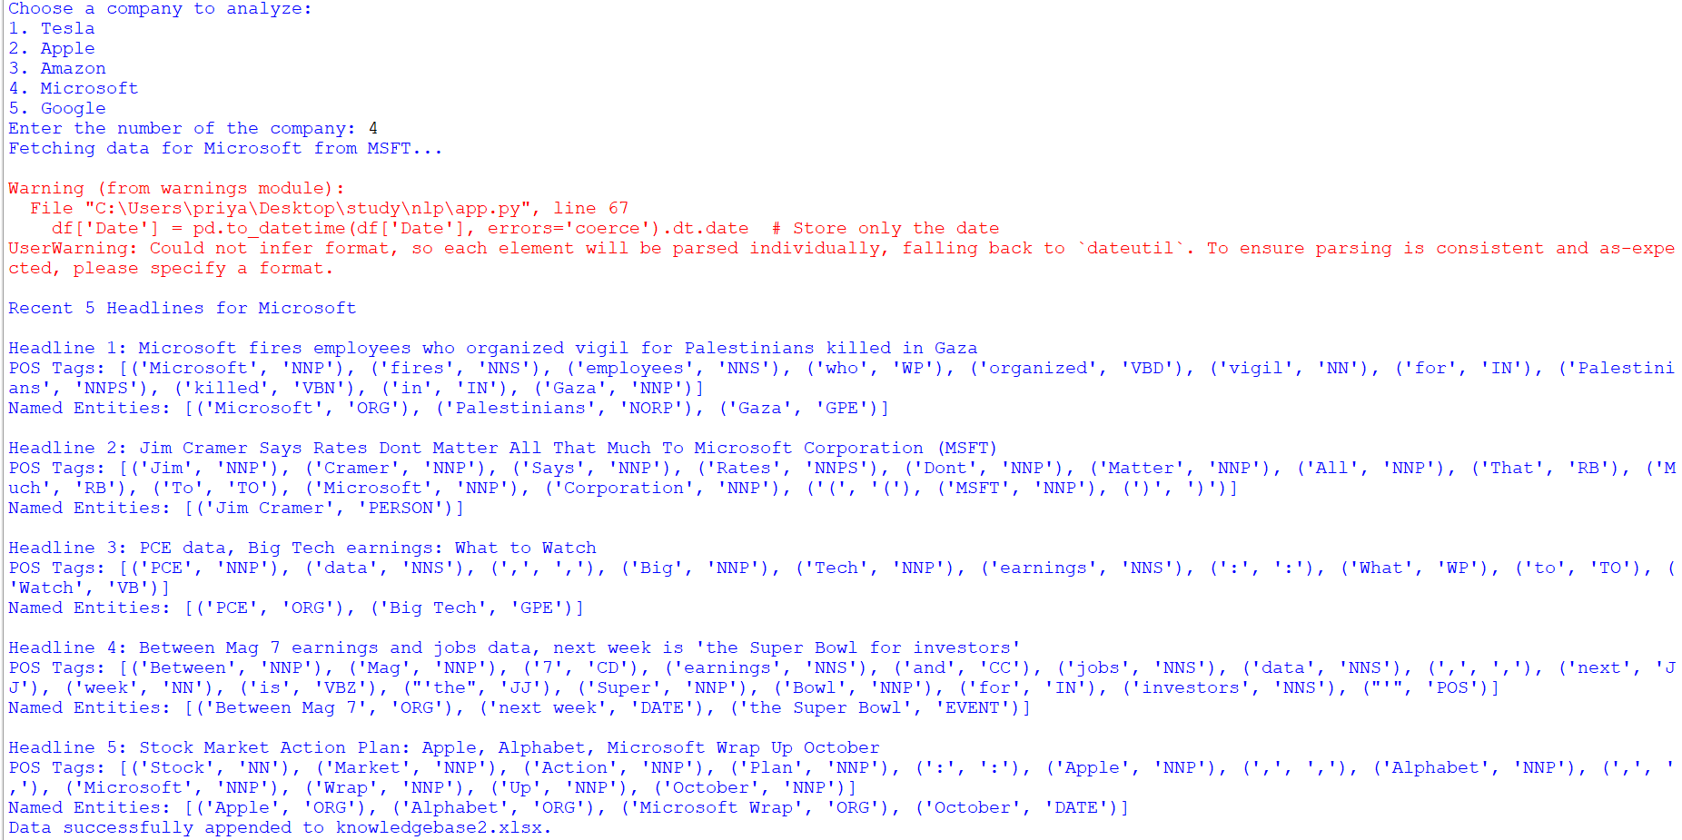

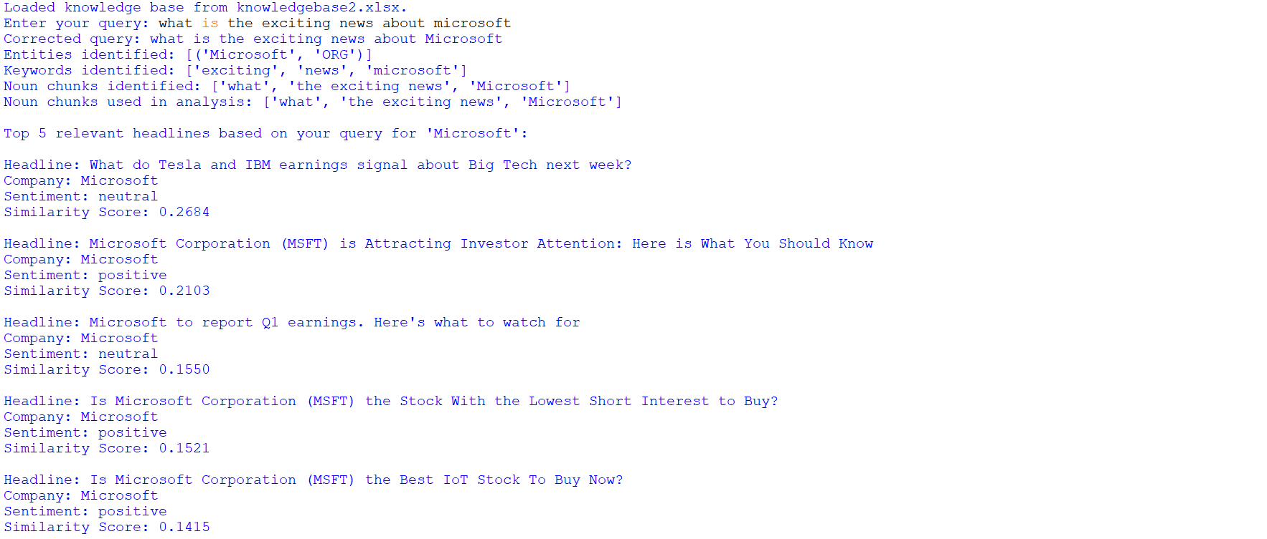

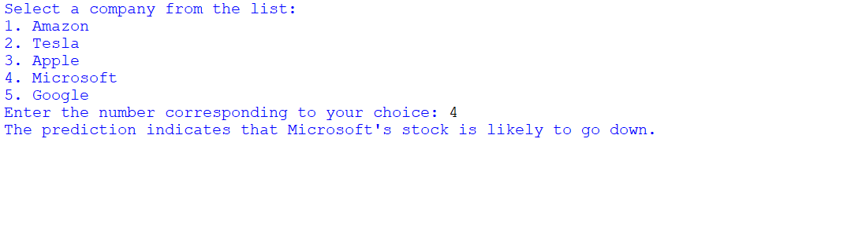

**Conclusion**

The project successfully demonstrated how NLP techniques could be applied to analyze stock-related news articles. We web scraped the latest article headlines of five companies, applied POS tagging and NER, and analyzed the sentiment, storing this data in a knowledge base. A semantic analysis module matched user queries with relevant headlines, providing insights into the news most pertinent to the query. The stock movement prediction model helped forecast potential stock trends based on sentiment, offering a valuable tool for investors. The implementation of retry mechanisms and data storage safety checks ensured robustness and reliability throughout the analysis, making this project adaptable for a broader range of companies and financial needs.